Draft of the report for the 1-3 lab unit 2 (scripts on the git)

I started to generate data fron the t_sa_pizza table. First of all I created this table on user sa_pizza:

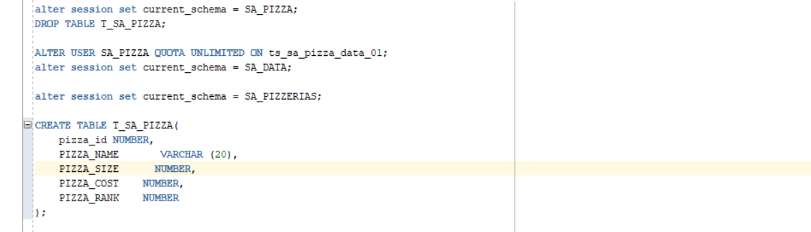

After generated data for this dimension:

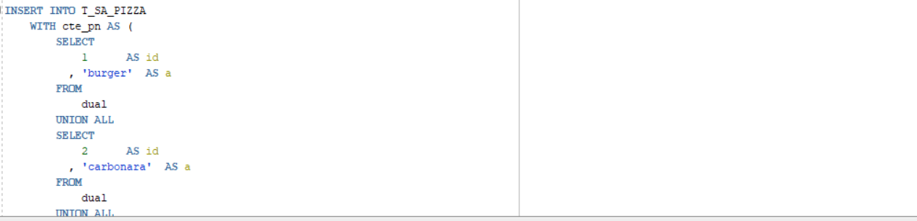

I generated 300000 values of pizza where the name, size, cost, rank are variated:

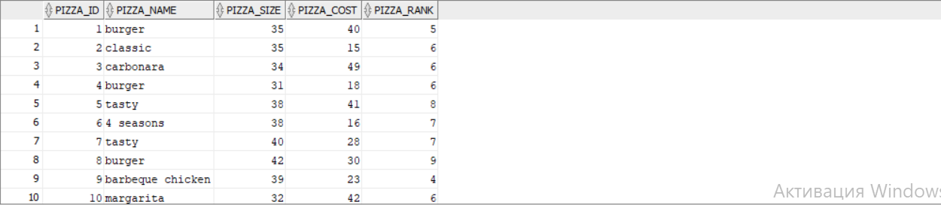

Next I created new dimension with name pizza_sales (it contains the information about delivery)

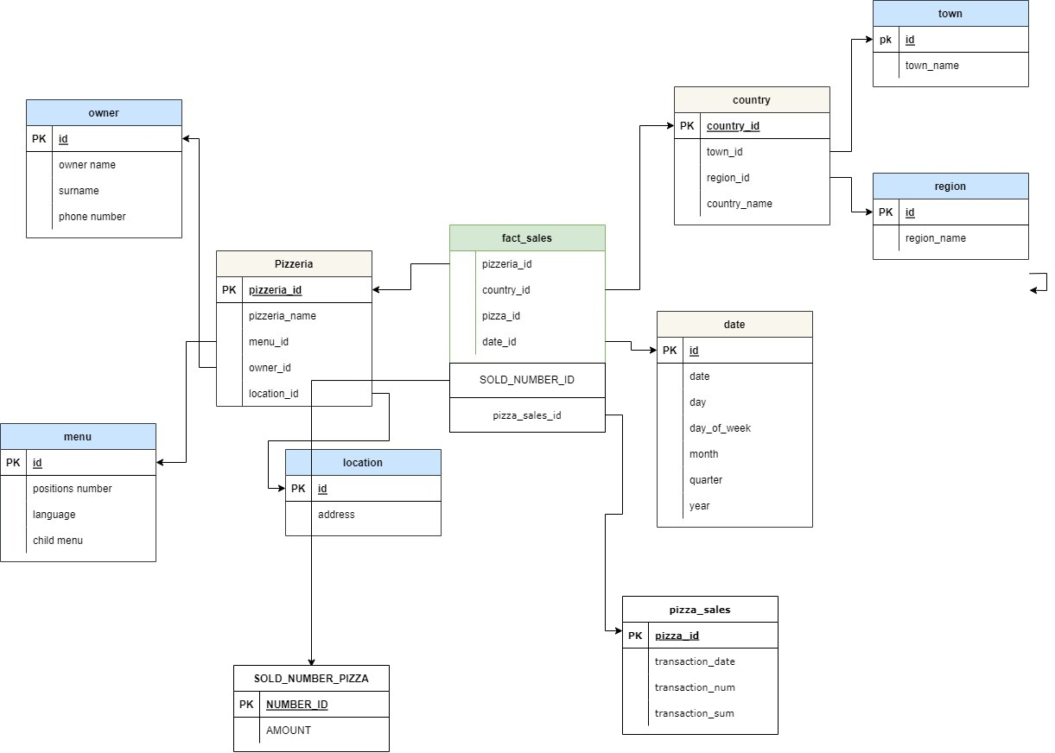

Table (it was difficult to generate the date)

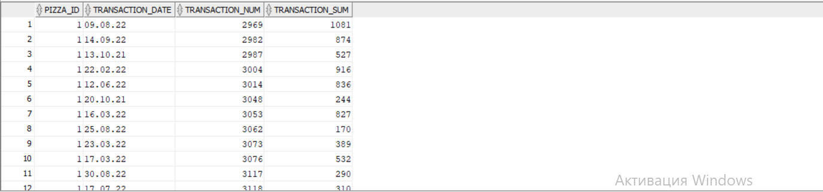

And the last I denerated the values for the sa_location table but I didn’t join it with other one :

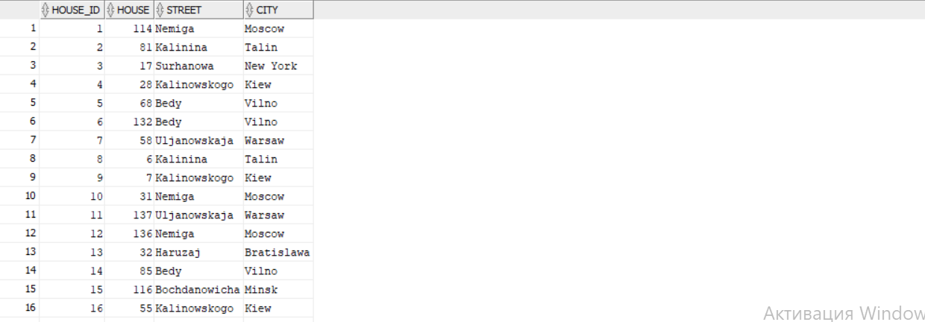

Later I generated the values for the sa_pizzerias table joined with sa_location od location_id:

